COMP 433

Mayukh Suri and Shefali Malhotra

Home work project# 2

In the project MyCart we have divided project into two

First is *Common* which has all the common files like Database Connection , Main and WebFunctionalities.

1. Database Connectionor

then we followed many tutorials for how to access database with JDBC and ORM. We have used JDBC for accessing the database as of now. Actually we are still struggling with ORM but will figure it out soon.

1. WebFunctionalities

This file includes the basic functionalities required for the service. As per the project requirement we have implemented the

* product search functionality,
* adding data of the customer to the database table Customer,
* order status and acceptance functionality and cancelling order
* order status

1. Main

Then We have another module *Tables* that includes all the classes of tables that exist int the database.

1. Customer
2. Product
3. Payment
4. Order

We have created a database named mycart and have inserted all the tables in the database.

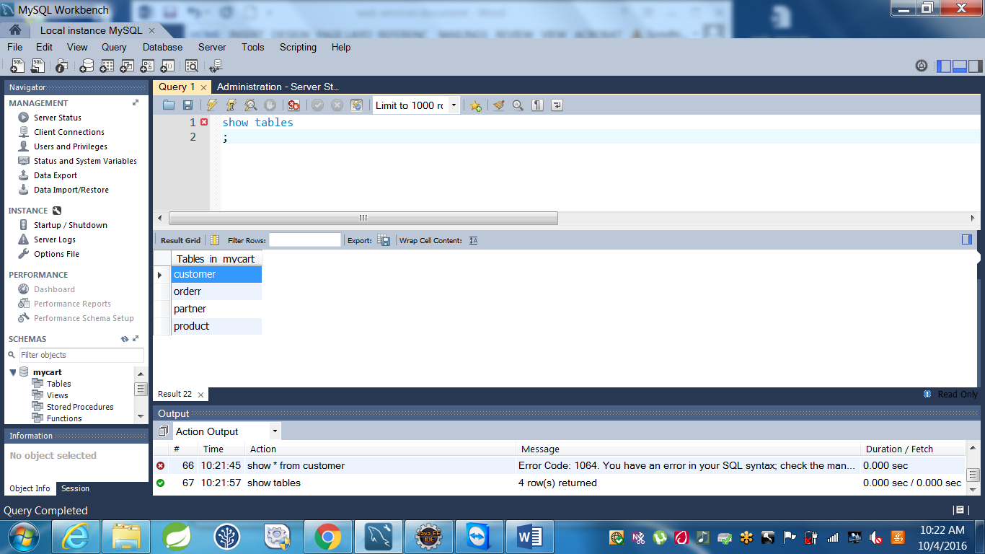

DDL statemenst for Database MyCart

create table Customer(

customer_ID int(5) not null auto_increment,

customer_phone int(10) not null,

customer_address varchar(25) not null,

primary key (customer_ID)

)

;

create table Orderr (

OrderID int(5) not null auto_increment ,

orderstatus boolean not null,

order_details varchar(25) not null,

orderdate TIMESTAMP DEFAULT CURRENT_TIMESTAMP,

orderquantity int(3) not null,

primary key (OrderID)

)

;

create table Product (

product_ID int(5) not null auto_increment ,

product_owner varchar(25) not null,

product_description varchar(25) not null,

unit_price int(3) not null,

primary key (product_ID)

)

;